30/04/2023 *Intro to OO Programming*

Lab practice Using Java programming languages

STUDENT NAME | COURSE NAME | INSTRUCTOR NAME/CLASS TIME/PERIOD

**ASSIGNMENT No. 1**

1. Write a java program that asks the user to enter two numbers, obtains them from the user and prints their sum, difference, product, and average.
2. Write a java program to asks the user to enter two integer numbers and compare them using if statements, relational operators and equality operators (==, >, <)
3. Write a Java program to change the time in seconds to minutes
4. Write a Java program that prints the following table (only use a print method an escape Characters in Java):

_____________________________________________________

No. 10*No. 100*No. 1000*No.

_____________________________________________________

1 10 100 1000

2 20 200 2000

3 30 300 3000

4 40 400 4000

5 50 500 5000

1. Write a java program that prints the following shapes with asterisks (only use a print function an escape Characters in Java):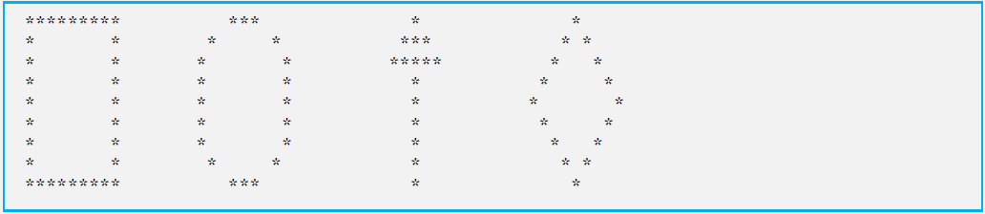

Student Name: _SARA HACHECHE ______________________

Student ID: __5672186_____________________

**SOLUTION AND OUTPUTS ( SCREEN-SHOTS ):**

**1/**

.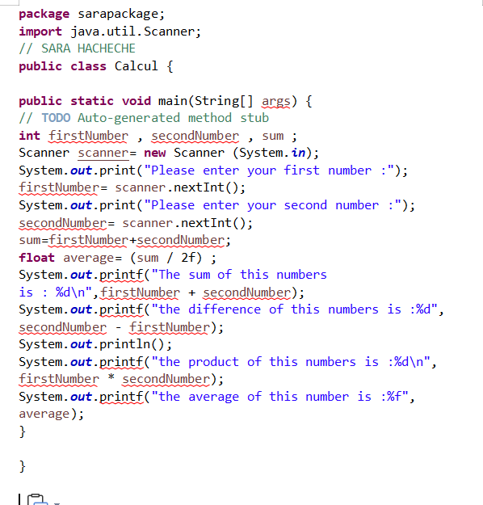

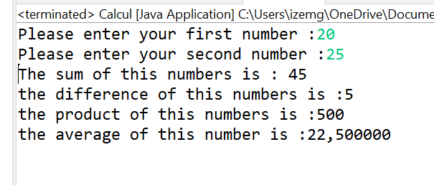

2/

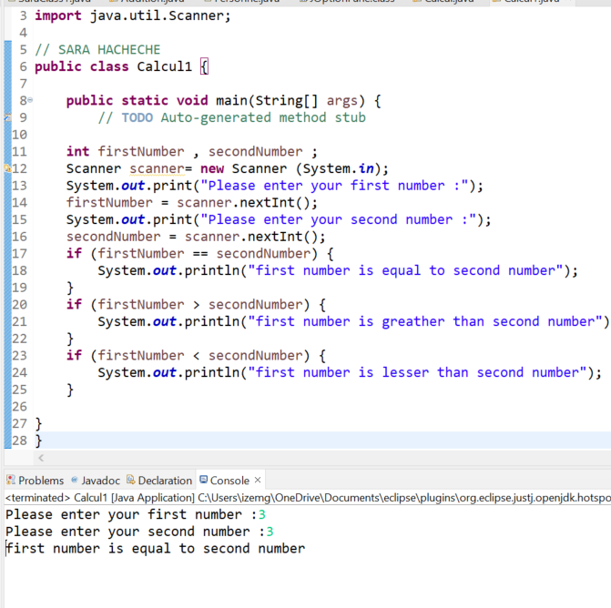

3/

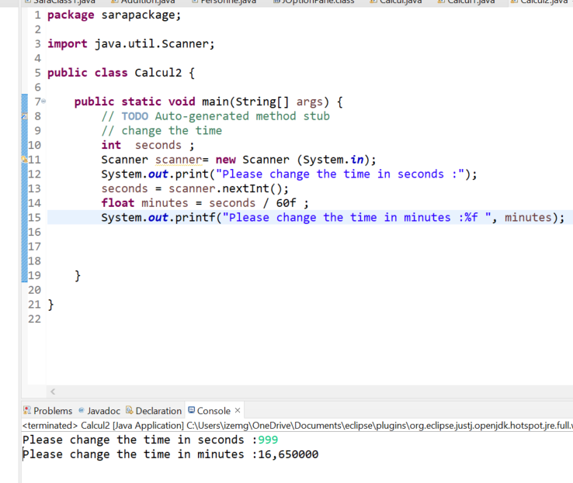

4/

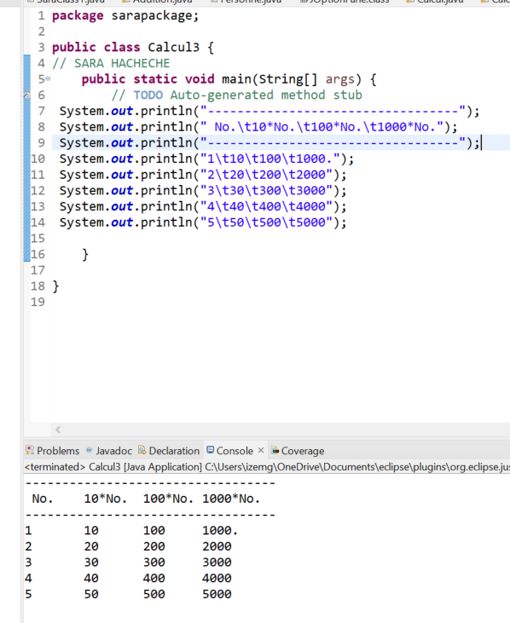

5/

